Injection of GOD’S love
(18 days therapy to fall in LOVE of GOD)
( Mantra YOGA)

There is a strong need to spread the fragrance of Love of GOD in the society since people suffer from the influence of love of materialism i.e. artificial bliss resulting in artificial intelligence. Human life is precious gift of GOD & is not be wasted away in remaining busy in enjoying worldly bliss. Is there a smart route available to a common man to get rid of this ailment of psychological nature ? Society has many clever people who have taken over the role of acting as messengers of GOD!!!! This makes the situation even worse; very sad indeed!!!!!! Where is the simple remedy available to a young man to overcome the effects of artificial intelligence bliss & feel the bliss of JOY of bliss of GOD’S Love ? Here is the sneak peek into its revelation that will benefit one & all.
The therapy of 18 days was blessed to the humanity of our planet by His Holiness Baba Nand Singh Jee, the greatest SAINT of last millennium ( 28 Nov 1868 to 29 Aug 1943) who successfully enjoyed the Love of Sat Guru Nanak ( Guru Granth Sahib ) i.e. NAAM DAAN. These blessings were given in LOVE of humanity as a result of humble submission of Sir Rai Bahadur Singh Jee from DELHI to feel the JOY of GOD’S love . Since it was
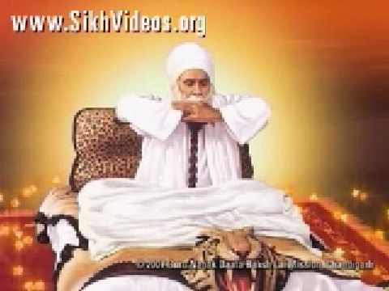
difficult for him/everyone to spare 3 hrs time daily for meditation due to pressure of duty/work suffered to survive & make both ends meet.
https://www.youtube.com/watch?v=3yTI9w4biEQ
This meeting was held during the year 1939 in District Ludhiana, Tehseel Jagraon & Village Kaleran Punjab India. Prior to this Baba Nand Singh Jee had meditated for 12 long years wef the year 1896 to 1908 by chanting Mool Mantra (35 Million times) without sleep even for a second.(See details of Mool Mantra). The result of meditation was getting a boon of NAAM DAAN from Sat Guru Nanak . This is the latent gist/light of Vedas. Geeta of Brahmgiani Ashtawark Jee highlights the same content. Prabhu ka NAAM is supreme & is even higher than GOD. This is the light of truth. Gurbani confirms ,
“ Vaddhha sahib uochha thaon
Uchhey uppar uchha Naaon …’’
NAAM is a state of enjoying Infinite Bliss of Love of Truth inside our heart (Shabd GURU). Baba Nand Singh Jee enjoyed for over 35 years till the age of 75. Bliss means LIGHT/PRAKASH to the mind & heart. As per VEDAS, it is ,
“Nirgunam ,Niranjanam,Sanathana,Sadhana,- Niketanam,Nitya, Suddha, Buddha , Mukta, NirmalaSwarupinam” (It is attributeless,unsullied, final abode, pure,enlightened, free& embodiment of sacredness.)
It is different from financial bliss of US$01 Billion/Million. The therapy of 18 days implies that one (belonging to any religion) has to enjoy reciting/chanting/simrann of Guru Mantra daily after taking bath & sitting with straight back position in sukhaasan on a ground sheet/durry during ambrosial hours i.e. wef 0400 hrs to 0700 hrs at home.(During Amrit Vela). This challenge of 18 days is to be accepted only once in life time. One can start wef 0700 hrs initially with a strong will & also need not feel disheartened if mind wavers during first ten days. Mind wavers due to pollution created by ego.
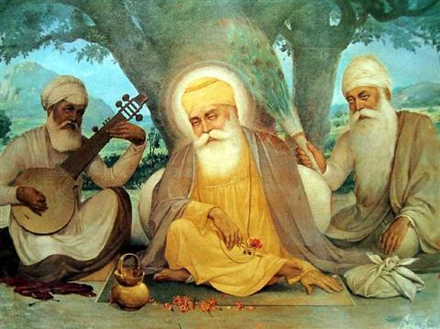
The result is positive in getting pleasure of GOD & boon of enjoying GOD’S Love. This act of devotion is like getting an injection of GOD’S LOVE. GOD has been defined by Sat Guru Nanak as, ” Infinite bliss of love of truth personified”. He blessed the humanity of our planet with the latest designed religion (way of life) & thus brought for them true feelings of freedom in their daily life, which otherwise was suffering from lack of knowledge of liberation.
Result is guaranteed to every seeker of truth belonging to any religion anywhere in the world. The successful journey of life starts from this moment onwards wef the 19th day. You are blessed with full throttle blessings/love of GOD/Maa Saraswati Devi which results in shining of mind (bliss) & this facilitates in feeling the JOY of learning in studies as well as playing games in school/college life & thereafter.
Modern education system has been designed to give a scientific approach of thinking & becomes a very simple as well as interesting affair. Every young child/person enjoys running & playing games. Body sweats in this process & makes it healthy. Similarly mind desires to be in state bliss (Anannd). The therapy explained above facilitates to achieve health & mental bliss & is guaranteed to every seeker of truth. One makes a head start in daily life & understands the precious value of every minute/hour/day .
Maan Sarasvati Devi
( Goddess of Education)
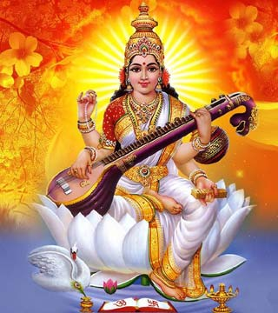

Mind is the child of electron size soul (energy) & only when soul penetrates the mind , it feels the bliss state . Gurbani confirms ,
‘’ Mann tuun jyot saroop hain
Aapna mool pachhan…….’’
His Holiness Sathya Sai Baba also desired that we as human beings must strive hard to enjoy GOD’S LOVE & be a good human being. This is the real wealth of life. The power of this LOVE develops in you a strong positive attitude in life which is full of compassion, forbearance & an attitude of gratitude infinite. It also facilitates you to start enjoying a stroll after bath during the sun rise phase for 25 minutes duration ( changing of orange red color of the sun into white ) & get fully charged with energy for the day’s work.
In this state all negative feelings inside the heart i.e. hatred, jealousy, grievance & anguish vanish since now you belong to the group of GOD’S beloveds. The digestive system improves tremendously & you feel hungry 3 times a day. You enjoy deep sleep of 6 hours in the night since you start moving in the direction of getting health bliss & get a blooming face.
For those who feel this challenge is difficult ,it is recommended for them to view the sun rise phase ( sun changing its color from orange red to white in 25 minutes) after bath daily for 18 days. It facilitates to get the necessary will power to accept the challenge of taking injection of GOD’S love. Personal hygiene of high level is very important aspect of our daily life i.e. cleaning of mouth & nostrils by doing gargles & neeti kriya. Baba Ramdev has successfully spread this message at global level & UNO has declared 21 JUN to be observed as Yoga day .
Sun rise phase is a very important aspect of the day.
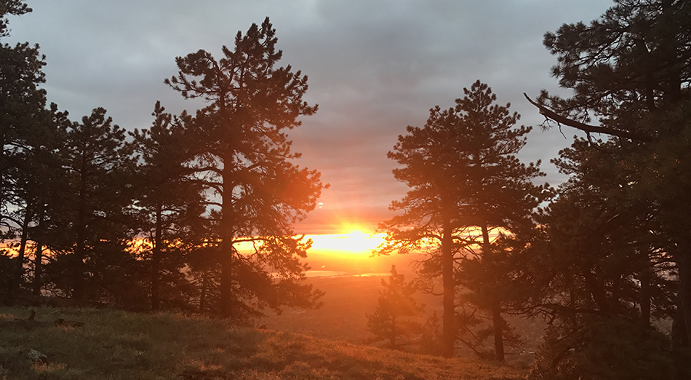

Sanathan Sarthy is a monthly magazine in English/Hindi brought out by the legacy of Sathya Sai Baba & its reading during ambrosial hours gives you spiritual empowerment to perfect the art of speaking the truth & this facilitates in getting excellence in communication in English/Hindi/Punjabi etc. It contains discourse of His Holiness Sathya Sai Baba ( Lord Krishna) in simple English. A blissful mind alone makes a healthy body free from all kinds of ailments !!!!!! A blissful mind alone is fearless !!! Without a blissful mind we become the greatest coward on the earth which is avoidable.
His Holiness Sathya Sai Baba
(23 NOV 1926 to 24 APR 2011)
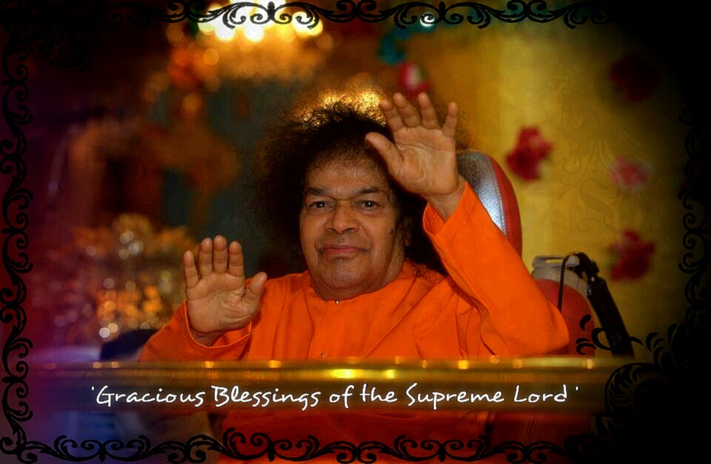

The people of other group who suffer from ill effects of ego do not enjoy Love of GOD & are devoid of this Love since they try to follow the short cut by following the traits of Duryodhan / Ravan/ Hitler i.e Use of cigarettes, liquor, drugs, non veg & extra martial sex etc….. Running for respect in society is a cancer to the mind !!! Everybody desires to live the life of a good human being with humility & with an attitude of love in behavior i.e. enjoy excellent relationship with the group of beloveds of GOD.
Now you are blessed with infinite compassion, immense tolerance power & blissful intelligence which results in realizing your hidden potential physical & mental both to the optimum level (infinite).This is also termed as awakening of kundalini power. Since effect of five evils present inside vanish . The listening skills of appreciation of any issue improve tremendously. This is how one makes a head start in life. Your blissful attitude of love improves your learning intake power to almost infinite level.
Bhagat Kabeer Jee
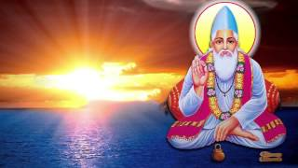
Bhagat Kabeer Jee in his Gurbani inspires the youth to enjoy GO’DS Love at an early age of only 5 years by siting the example of Prahalad & Dhroov of ancient times. He says ,

‘’ Raam jappyoo jeeo aissey aissey
Dhroov Prahlad japeyyo jaissey………’’

https://www.youtube.com/watch?v=a8TFJFsrnF8

Who will desire to miss this way of life since the parents & staff members at school & college have a serious concern to see the students blooming in education phase of life?
Life gifted by GOD is precious & its purpose is to enjoy GOD’S LOVE always & succeed to enjoy glimpse of his KINGDOM inside the spiritual heart. Education phase in life is to achieve academic as well as physical excellence with above mentioned short cut by taking an injection of GOD’S LOVE. End of education is character. Information shared is for the benefit of seekers of truth since is not bookish nor is for ego boosting but is based on real life experience. With divine love
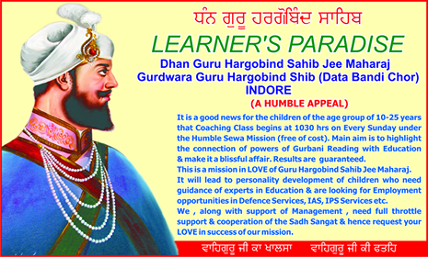
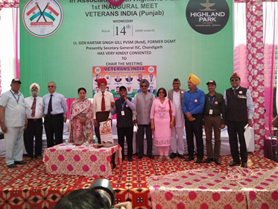

Waheguru mantra video link
https://www.youtube.com/watch?v=Gi1OQ41MiRk
https://www.youtube.com/watch?v=NFPcNQdO3Bk
https://www.youtube.com/watch?v=TKze7Y5plYI

References
Website refers www.fleeky.one
- Biography of Baba Nanad Singh Jee written by Bhai Gurmukh Singh Jee. His mentor was His Holiness Baba Mahaharnam Singh Jee (1787 to 1927 , Village Bhuchhon Kalan , 18 KM from Bhatinda District PUNJAB. Video link & photo is shown below.
https://www.youtube.com/watch?v=dhQTbSnXbXo
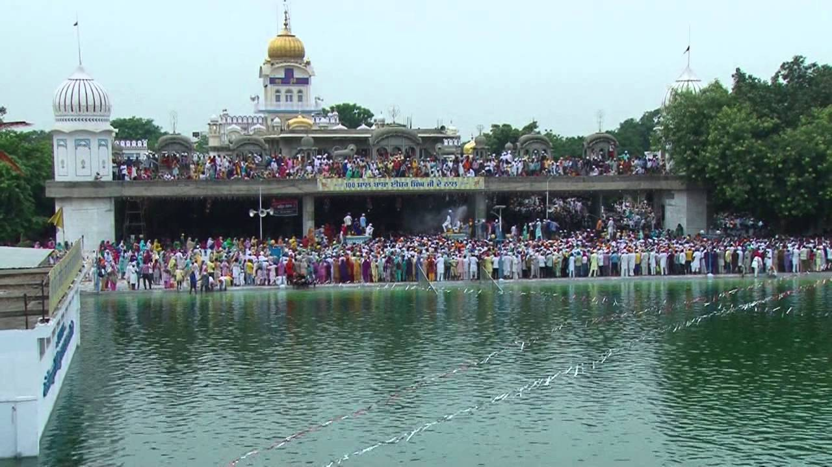

- The present main place of Baba Nand Singh Jee is situated at Village Kaleran, Tehseel Jagraon District Ludhiana, Punjab, INDIA. However there are over 700 centers which are spread all over the globe in his LOVE.
- It is also worth visiting for a day PrashanthiNilayum, Village Puttaparty District Anantpur Andhra Pradesh where you find a super specialty hospital giving treatment free of charge, international stadium, Sai
University, auditorium, library, living accommodation for Visitors & the air port etc. On his 75th birthday over a million people from 170 countries joined Him to enjoy his glimpse. The information shared is based on real life experience during College days of MAY 1968 as a student of IV Year Engineering with excellent results & later in ARMY service. Video link
of Prashanti Nilayam Puttaparty is good to look.

https://www.youtube.com/watch?v=5fSBjL9zVyU

- Discourses of Sathya Sai Baba
- Book on Management by SathyaSai Baba
- Sanathan Sarthy monthly magazine in English.
- The Holy Baba & the Psychiatrist written by Dr Samuel Sandweiss MD from California USA
- Mool Mantra IkOmngkar , satnaam , kartapurukh , nirbhaov, Nirvair, akalmoorat , aajunisahbhang , Gur Prasad , Jap Aad Sachh , Jugad Sachh Habhee Sachh , NANAK hossee bhee sachh, Waheguru Waheguru Waheguru Waheguru .
Mool Mantra depicts the qualities/attributes of the Lotus Feet of GURU/GOD. Maximum we can be blessed with is

” NIRBHAO” i.e. FEARLESSNESS in life.

The founder of Sikhism, Guru Nanak Guru Nanak © Guru Nanak (1469-1539) was one of the greatest religious innovators of all time and the founder of the Sikh religion. Guru Nanak’s birthday is celebrated by Sikhs on 20 NOV . The date according to the lunar calendar changes annually but is usually in November.) –
Guru Mantra
- For Sikhs …………… WAHEGURU
- For Hindus……………RAAM RAAM
- For Muslims…………YAAH KHUDDA
- For Christians………GOD –GOD

- Ajeet Singh Mac Formerly Major Corps of EME, INDIAN ARMY
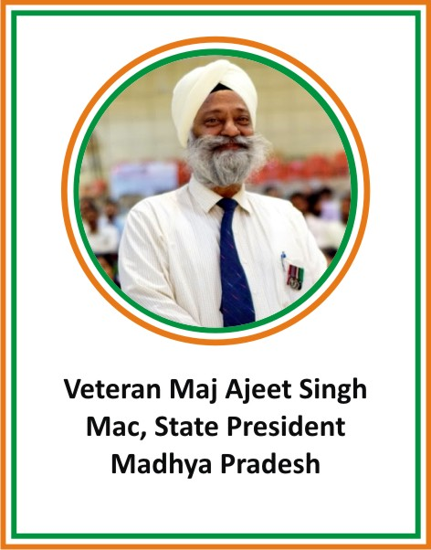
For details on Kundalini Powers , look at the blog posted
On my website www.fleeky.one

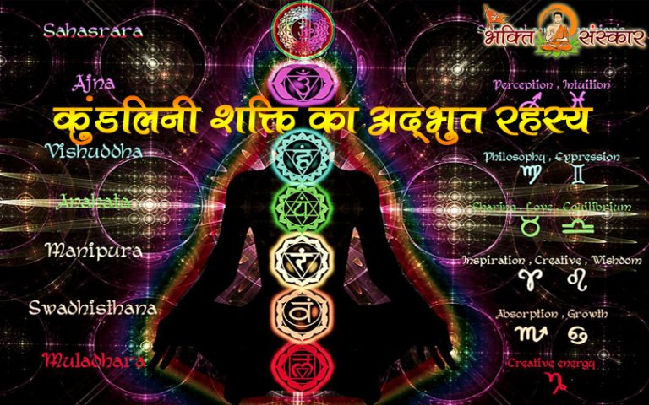
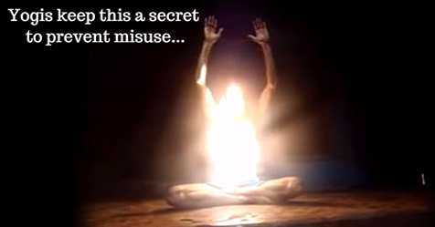
Following video links are also interesting.
https://www.youtube.com/watch?v=KlITeRcTZsc
https://www.youtube.com/watch?v=gUt8OOkpJwU
https://www.youtube.com/watch?v=WMhJgdpj1d0
https://www.youtube.com/watch?v=OpTOlAZpjv0
https://www.youtube.com/watch?v=iy-KpOhLsJY

