‘’ Koyee jan harr so devey Jor…’’
Injection of GOD’S love
(18 days sanjog therapy to fall in LOVE of GOD)
(Powers of Mantra YOGA)
- There is a strong need to spread the fragrance of Love of GOD in the society since people suffer from the fever of love of materialism i.e. artificial bliss. Is there a smart route available to a common man? Society has many smart people who have taken over the role of acting as messengers of GOD!!!!
This makes the situation even worse; very sad indeed!!!!!! Where is the simple remedy available to a young man to overcome it? It is now being revealed benefiting one & all. This therapy of 18 days was blessed to the humanity of our planet by His Holiness Baba Nand Singh Jee, the greatest SAINT of last millennium ( 28 Nov 1868 to 29 Aug 1943) who

……Contd Page 2

-2-
successfully enjoyed the Love of Sat Guru Nanak ( Guru Granth Sahib ) i.e. NAAM DAAN( Prabhu ka NAAM).

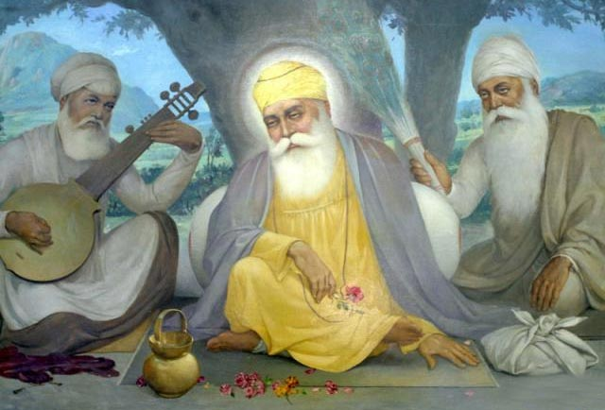

‘’ Dhan Guru Nanak Tuhi hi Nirankar ‘’

These blessings were given to humanity a result of humble Submission for enjoying GOD’S
….Contd Page 3
-3-
LOVE by Sir Rai Bahadur Singh Jee from DELHI since it was difficult for him/everyone to spare 3 hrs time daily for meditation due to pressure of duty/work suffered to survive & make both ends meet.
Hence the need of injection of GOD’S LOVE was felt & revealed for the benefit of humanity . This incidence took place in the year 1939.

3 Prior to this Baba Nand Singh Jee had meditated for 12 long years wef the year 1896
to 1908 by chanting Mool Mantra without sleep even for a second.(See details of Mool Mantra)

4 The result of meditation was getting a boon of NAAM DAAN from Sat Guru Nanak . This is the latent gist/light of Vedas. Geeta of Brahmgiani Ashtawark Jee highlights the same content. Prabhu ka NAAM is supreme & is even
……..Contd Page 4

-4-
higher than GOD .
Gurbani confirms ,

“ Vaddhha sahib uchha thaon
Uchhey uppar uchha Naaon …’’

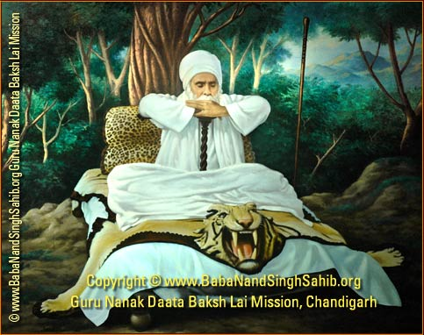

5 NAAM is a state of enjoying Infinite Bliss of
Love of Truth inside our heart ( Shabd GURU).

……….Contd Page 5

-5-
6 The therapy of 18 days implies that anyone (belonging to any religion) need to enjoy
reciting/chanting/simrann of Guru Mantra
daily after taking bath & sitting with straight back position on a ground sheet/durry during
ambrosial hours i.e. wef 0400 hrs to 0700 hrs
home.(During Amrit Vela).
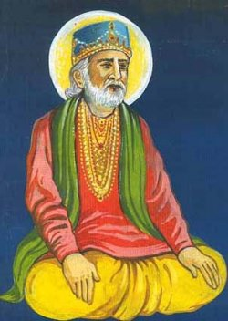
Bhagat KABEER JEE in Gurbani highlights its importance,
‘’ Raam japoo jeo aisesy aisey
Dhroov Prahlad japyo harr jaisey…….’’ ……..Contd Page 6
-6-
7 This challenge of 18 days is to be taken up only once in life time. The result is getting
pleasure of GOD & boon of enjoying GOD’S Love. This action/devotion is like getting an injection of GOD’S LOVE. How to start ???
One can begin even with wef 0700 hrs . It takes
One week time to eliminate pollution of mind suffering from ego & one need not feel disheartened during this phase.
8 Results are guaranteed for every seeker of truth belonging to any religion anywhere in the
World & get experience the JOY of LOVE of
GURU/GOD.

………..Contd Page 7

-7-

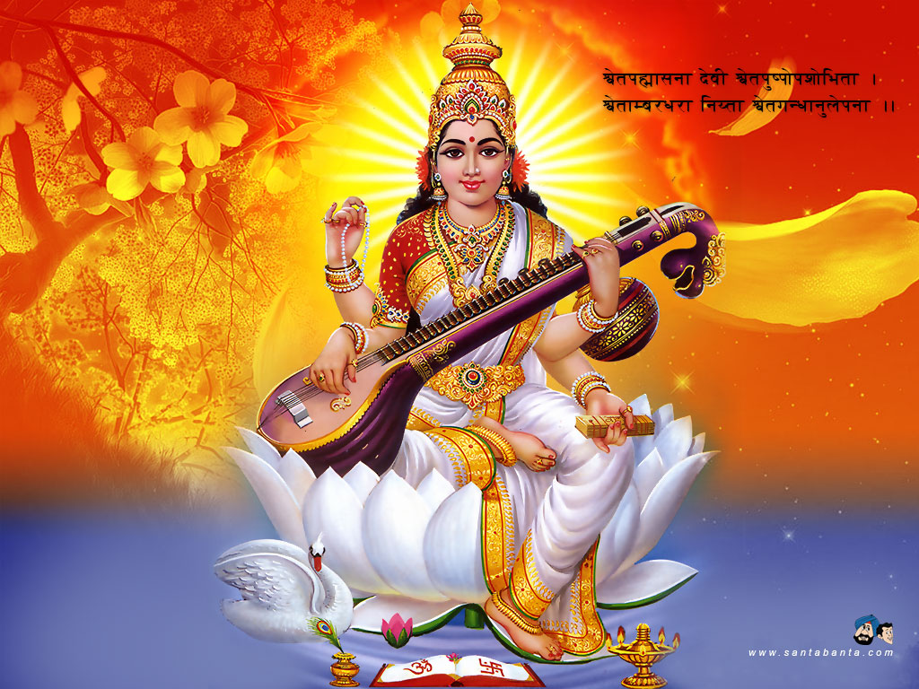
9 The successful journey of life starts from this moment onwards wef the 19th day.
You are blessed with full throttle blessings/love of GOD/Maa Saraswati Devi which results in shining of mind & this facilitates enjoying studies in school/college life & thereafter.
……..Contd Page 8

-8-
10 His Holiness Sathya Sai Baba also desired that we as human beings must strive hard to enjoy GOD’S LOVE & be a good human being

11 The power of this LOVE develops in you a strong positive attitude in life which is full of
Compassion in our heart.

12 It also facilitates you to start enjoying daily stroll after bath during the sun rise for 25 minutes duration & get fully charged for the
Day’s work.

13 All negative feelings inside the heart i.e. hatred, jealousy & anguish vanish since now you belong to the group of GOD’S beloveds.
The digestive system improves tremendously &
you feel hungry 3 times a day. You start moving in the direction of getting health bliss.

14 Sanathan Sarthy is a monthly magazine in
…….Contd Page 9

-9-
English & its reading during ambrosial hours
Gives you spiritual empowerment to perfect the art of speaking the truth & facilitates excellence
in communication in English/Hindi/Punjabi etc. It contains discourse of His Holiness Sathya Sai Baba ( Lord Krishna) on Geeta in simple English.
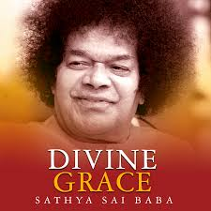

15 Healthy/blissful mind alone makes a healthy
body free from all kinds of ailment!!!!!!

16 The people of other group who suffer from ego do not enjoy Love of GOD & are devoid of

…..Contd Page 10
-10-
this Love since they try to follow the short cut
by following the traits of Duryodhan / Ravan/ Hitler i.e Use of cigarettes, liquor, drugs, non veg & extra martial sex etc…..

17 Everybody desires to live the life of a good human being with humility & with an attitude of love in behavior i.e. enjoy excellent relationship
with beloveds of GOD.

18 You are blessed with infinite compassion, immense tolerance power & blissful intelligence which results in realizing your hidden potential physical & mental both to the full (infinite).
Your listening skills of appreciation improve tremendously ( Kundalini awakening).
19 It also results in making a head start in life. Your blissful attitude of love improves your learning intake power to almost infinite level.

20 Who will desire to miss this way of life &
……….Contd Page 11
-11-
not be fearless since the parents & staff members at school & college have a serious concern to see the students blooming in life?

21 Life gifted by GOD is precious & its purpose is to enjoy GOD’S LOVE always & succeed to enjoy glimpse of his KINGDOM inside the spiritual heart. Education phase in life is to achieve academic as well as physical excellence with above mentioned smart cut of enjoying an injection of GOD’S LOVE & be a good human being.

With super powers of feelings of Divine Love

Ajeet Singh Mac
Formerly Major
President
Madhya Pradesh
VETERANS INDIA
INDORE-452014
Cell No 97556 48998

